Report of Academic Evaluation Program

## Introduction

In this assignment, our group aims to design a JAVA project which can help university evaluates their contribution to students’ future career. The project will allow users (faculty of university) to create, view, update and delete student documents which contain student’s basic information, course performance and job performance. Users will also be able to get a quantitative conclusion of the contribution. In the following part of the report, we will use sequence diagrams and object model to show the structure design and data flow of our program and we will also show the evaluation method we designed for the system.

The object model is a picture which can show all the object and list that will be created by the program, the picture will also show the attributes of which the object contains. The sequence diagram is a picture to show the data flow from one object to another. We think it is a good way to show users and other readers the concept and implementation of our program by combining these two charts together. In the following part of report, we will thoroughly explain the designment and thinking of these 2 charts.

## Sequence Diagram

A sequence diagram is a set-up of objects and messages [1]. The sequence diagram is given for the above model in Fig (1). Which is shows the checking of the performance of a student in whole courses during the academic years. It has five main objects which are shown on the diagram in a rectangles box with their class name. The five objects are Department Name, Student, Course Directory, Course Details and Exam. According to the sequence diagram, it records that all the lessons a student has taken during his or her school years and all the exam scores. Course details include course name, course number, teaching professor, course description and course keywords. Then, we store the information of these students in the college's information library. Therefore, we can show the course information and score of each college student one by one and compare the information.

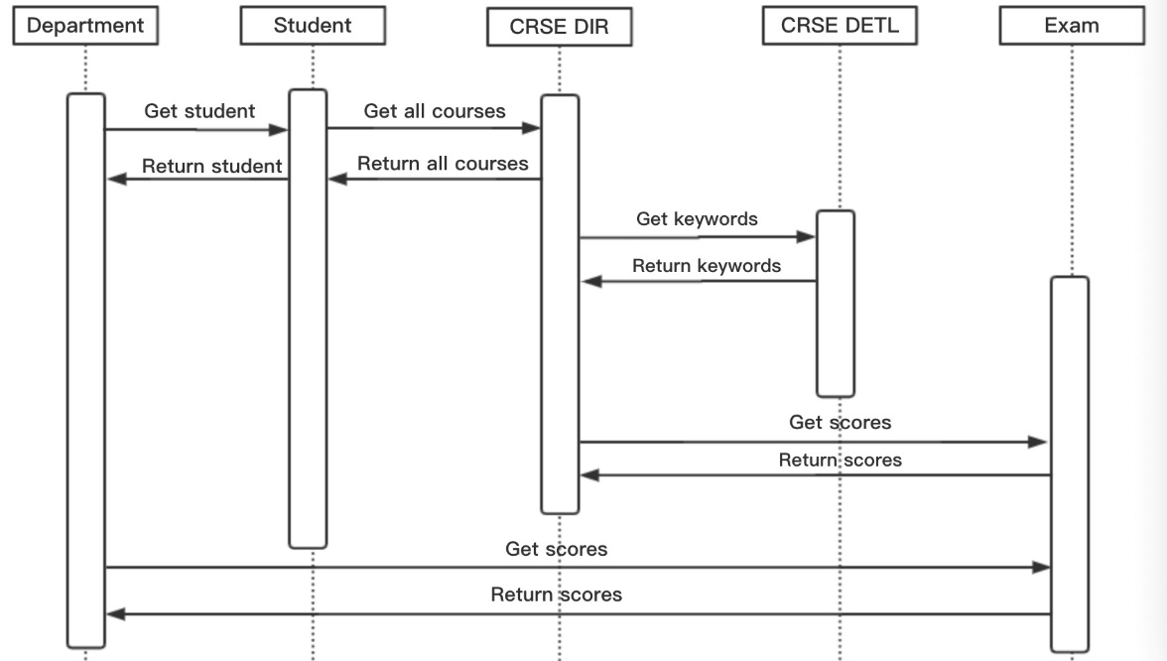

Fig (1)

This sequence diagram (Fig. 2) shows the checking of the job performance of the student after five years of graduation. It has five main objects which are shown on the diagram in a rectangles box with their class name. The five objects are Department Name, Student, Job Directory, Job Details and Salary. According to the sequence diagram, it records all job information and salary status after five years of graduation. Job details include job title, company name, rank of position, job keyword. Then, we store the information of these students in the college's information library. Therefore, we can show the job information and salary of each college student one by one and compare the information.

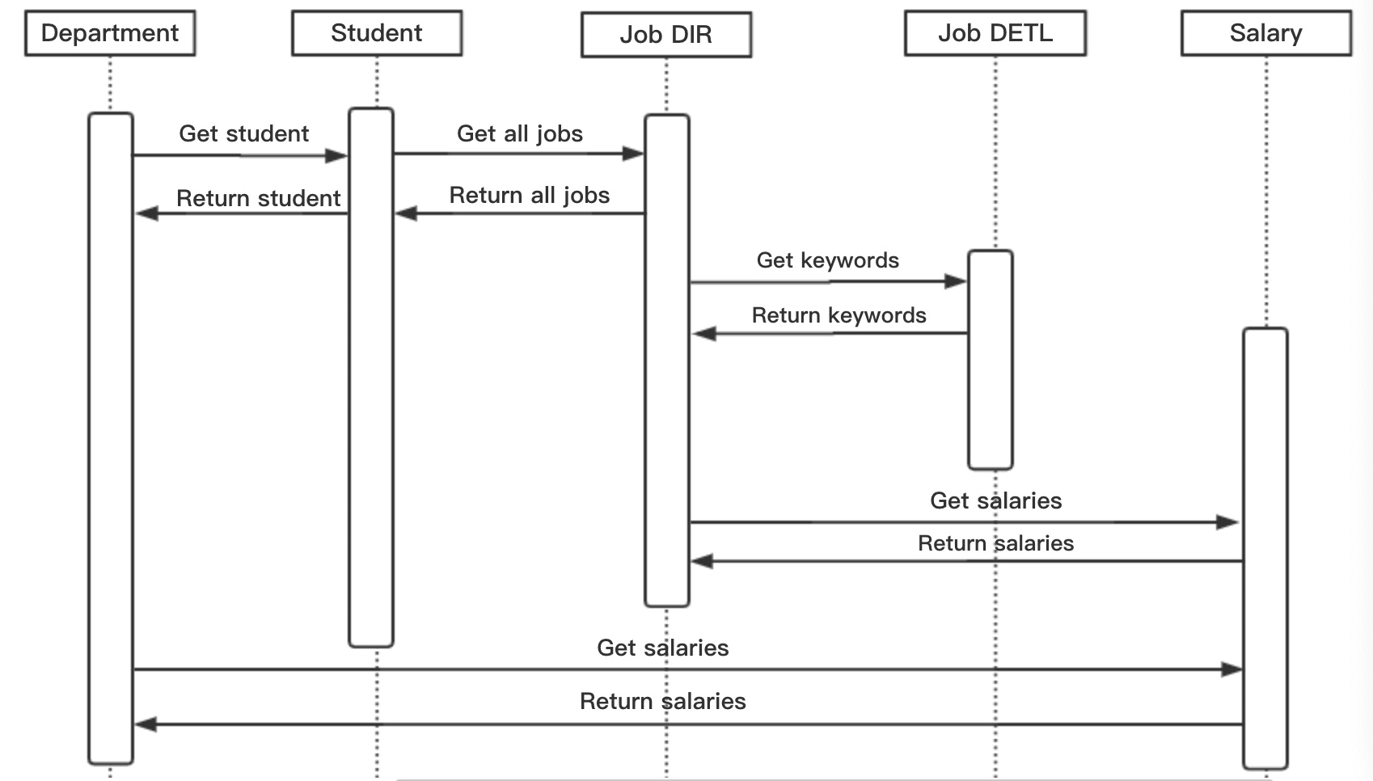

Fig (2)

This figure (Fig.3) shows the joint impact of work and on-campus courses on a student. By combining these two parts, we have a complete message of students and institutions to facilitate the evaluation of the performance of each college student.

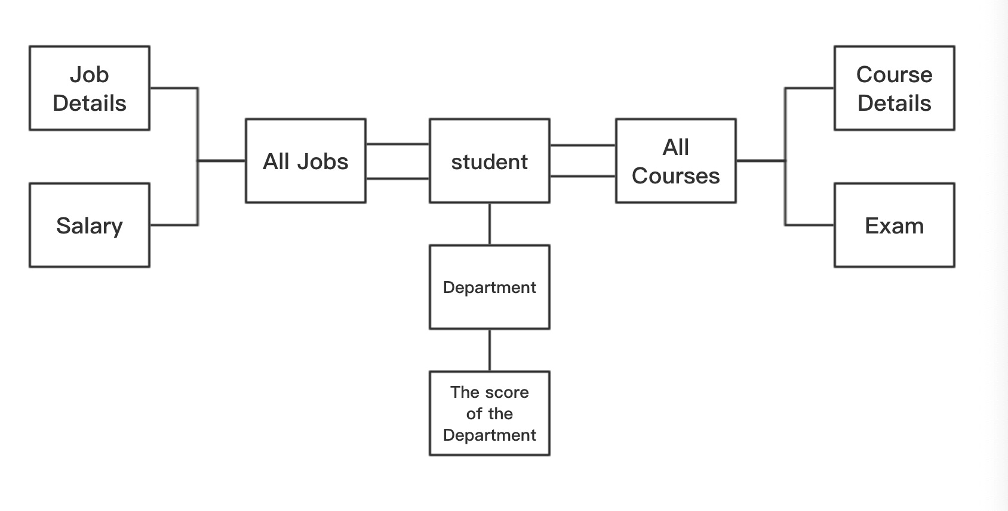

Fig (3)

## Class model

The UML class model shows the structural activities of the system, in which attributes and operations are designed [2]. Different properties like association, aggregation, inheritances are designed and shown in the UML class model. The complete UML modeling has been done for checking the performance of student in the whole courses which is shown in (Fig. 4). It shows the complete process of checking the performance of student along with courses are explained in the form of UML class diagram. The UML class model contains six major classes like Course, Course-Directory, Student, Department, Department -Directory. Course class has all the information about this course and the Department class has all the information about the students’ performance in school. The Student class has the students’ personal information and performance in the school. Especially, the keywords of the course are extracted from the class of the course and stored in the student's class so that they can be compared to the keywords extracted from the work class. The more keywords overlap, the more relevant the course and work are. Besides, test scores are also an important indicator. If the test score is higher, the student's ExamScore() will be higher. The Course-Directory class stores all the courses a student has, the Student-Directory class has all the students’ information and exam scores and the Department-Directory class has all the department scores and all the department information in this school.

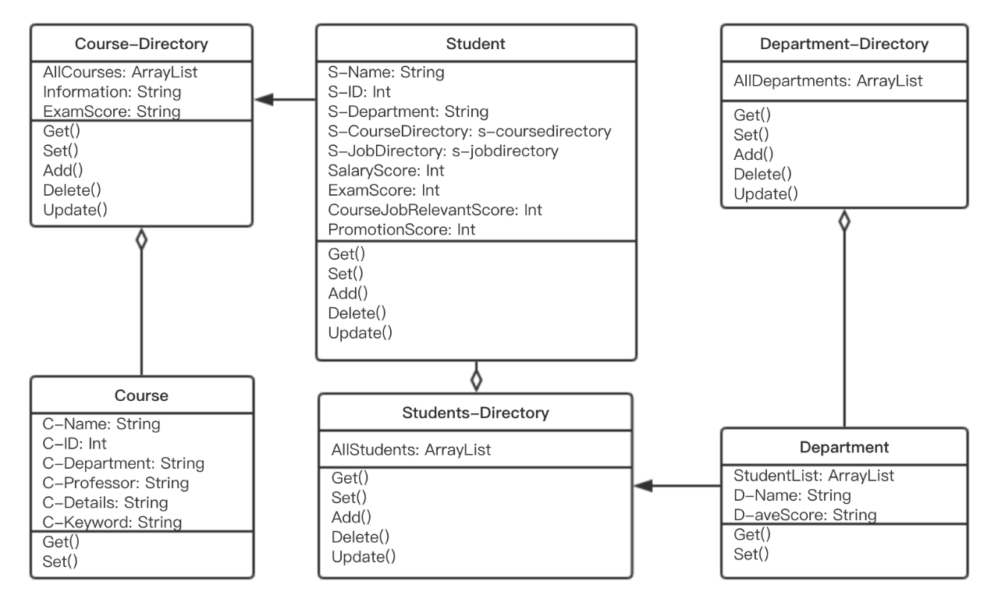

Fig (4)

The complete UML modeling has been done for checking the performance of student for their jobs which is shown in (Fig. 5). It shows the complete process of checking the performance of student along with job performance after five years graduation is explained in the form of UML class diagram. The UML class model contains six major classes like Job, Job-Directory, Student, Student-Directory, Department and Department-Directory. The Student class has the students’ personal information and salary, promotion course-job relevant score. The Job class has all the information about each job the student taken, and the Department class has all the information about the students’ and their performance score in their jobs. In particular, we will count his promotion times, and if his promotion is more, his promotion score will be higher. In addition, we will calculate his salary level, and if the salary is higher, his salary score will be higher. Besides, course and work relevance ratings are also included. The method is the same as above. The Job-Directory class stores all the jobs a student has, the Student-Directory class has all the students’ information and the Department-Directory class has all the department scores and all the department information in this school.

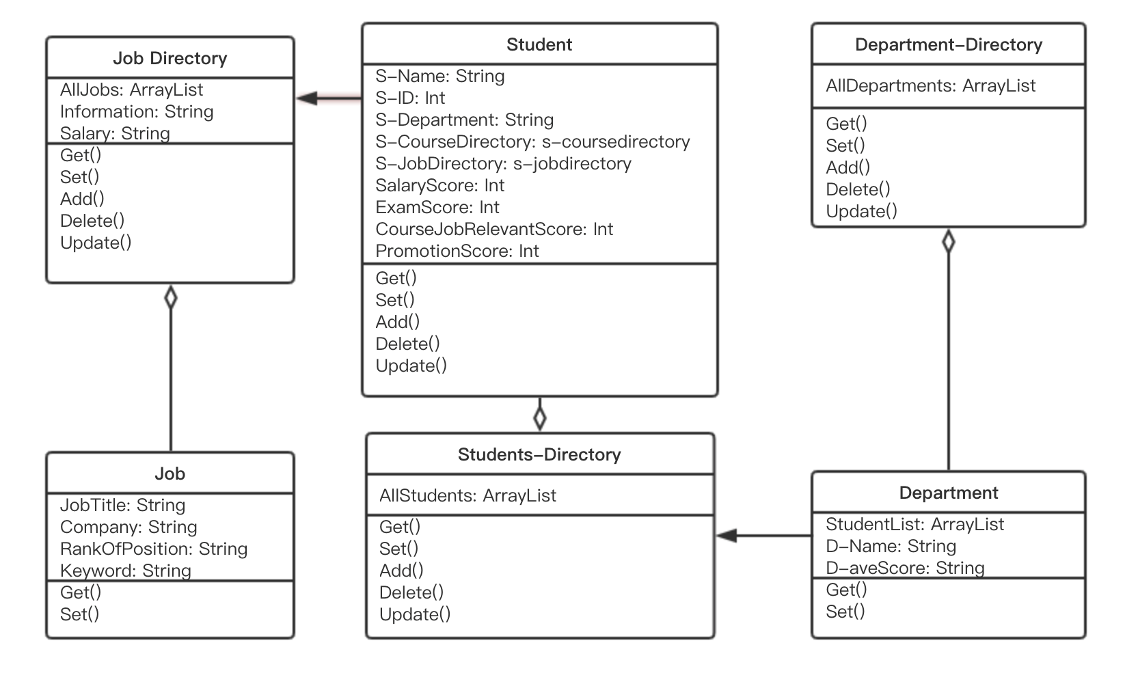

Fig (5)

## Dashboard

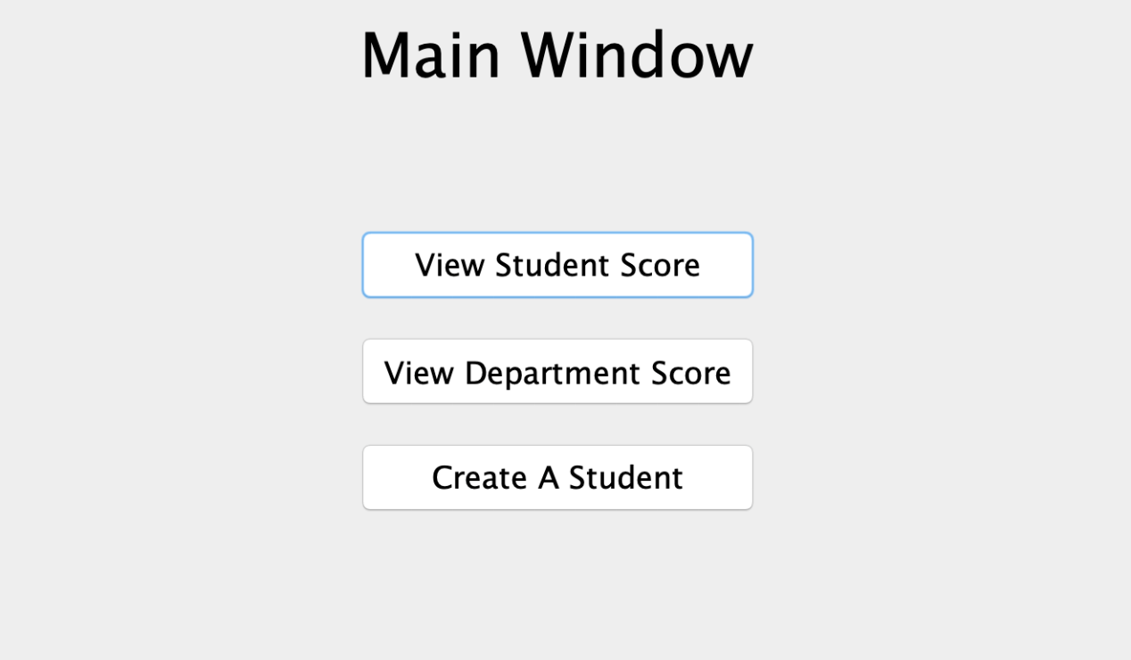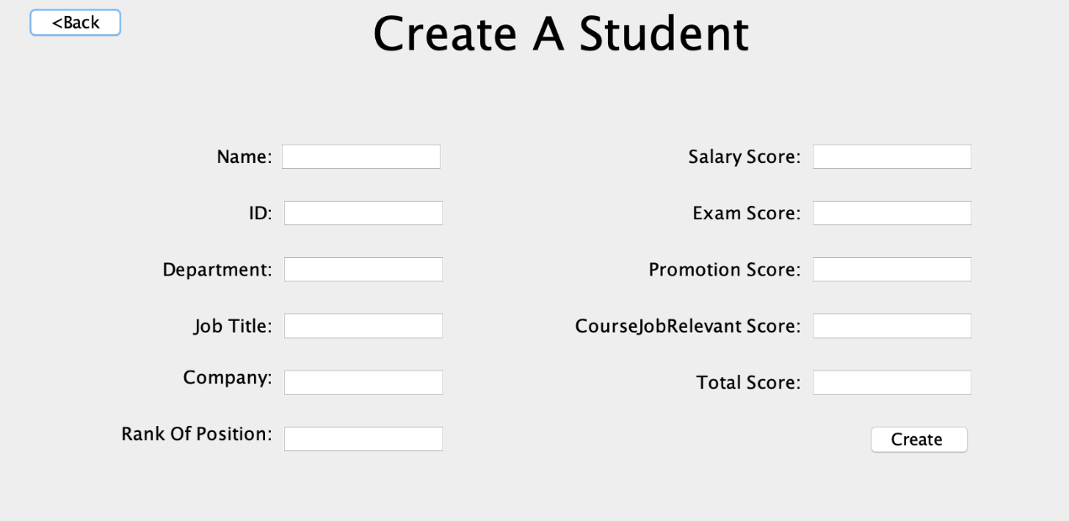

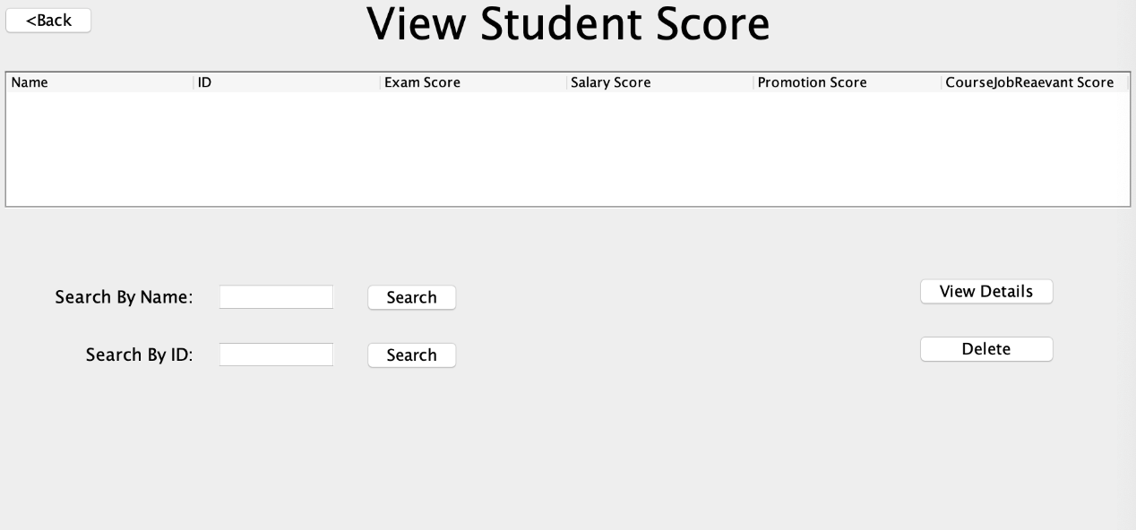

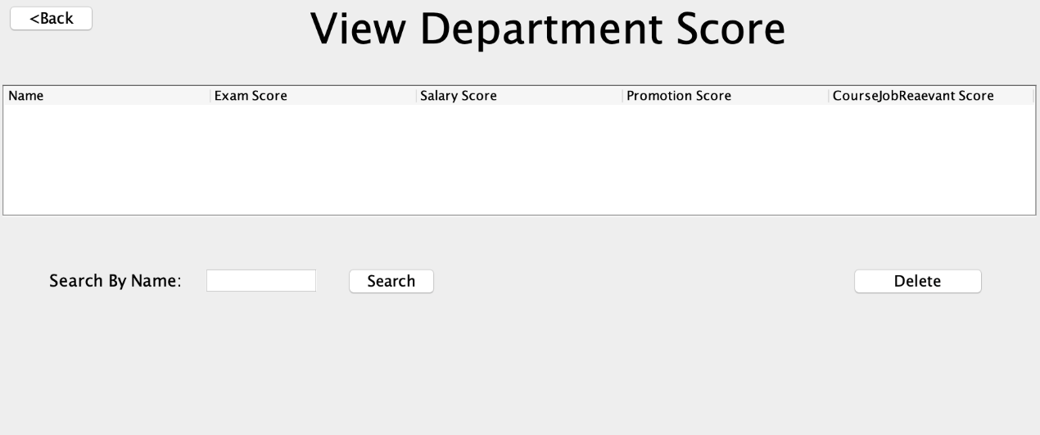

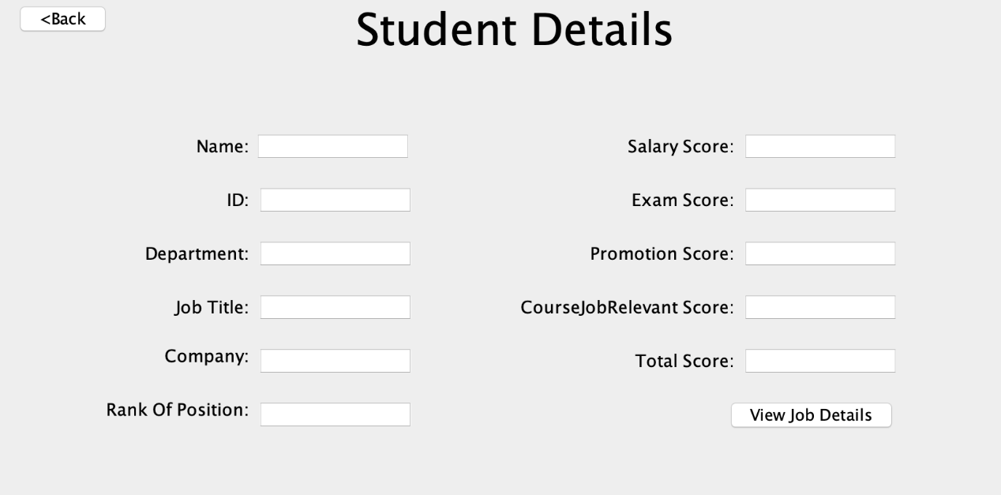

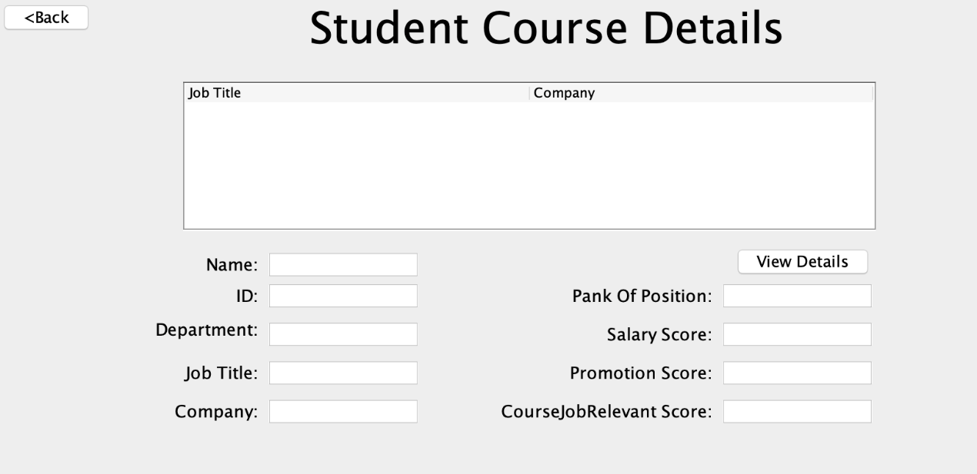

## Evaluation

As the introduction at the very beginning, using the program, users can input and update various kinds of information of students. But the final purpose of our program is not managing information of students but evaluating the influence and contribution of university study life to students after graduation in 5-year period. It is very difficult to say exactually how university study life has contributions to students’ job by words, so we design to use a formula to calculate the performance of students and the contributions of universities and courses, then the score of students, course taken by students and performance of students when they were at school..

The formula for evaluating the job performance considers many different factors, different factors will have different weight in the formula. Here we will show the parameters we design:

|  |  |
| --- | --- |
| Parameter | Introduction |
| Salary per month | The base of score |
| Rank of position | Different professional titles will have different parameters which will multiply to salary  Junior:1  Middle:1.2  Senior:1.4 |
| Promotion | The times of promotion will also be considered, the parameter will be:  1+promotion times x 0.1 |

For example, a student gets $8000 per month salary with middle professional title and has got 2 times of promotions after graduation in 5 years will get a score:

8000x1.2x(1+0.1x2) = 11520

By the formula we designed, this student will get 11520 score for his 5-year period job evaluation.

We choose to take salary as the basement to evaluate the performance because salary is the most important thing student will consider while finding job. And a company will basically give salary depending on the performance of its employee. Professional titles and promotion times are also independently considered because these factors sometimes do not directly influence salary but show the effort student puts on his or her work.

After giving each student a score, our program will also be able to show how a college contributes to students’ job career. There will also be a formula:

|  |  |
| --- | --- |
| Parameter | Introduction |
| All students’ number | The numbers of students who have studied in the college. |
| Job relevant | A method will return the degree of job correlation in int format (E.g. 1, 2, 3, etc.) |

College score= Sum (Single student job score x (1+degree of job correlation x 0.1))/All students’ number

For example：

For college of engineer:

Student 1 gets 12000 score and has 2 degree of job relevant

Student 2 gets 15000 score and has 1 degree of job relevant

Student 3 gets 18000 score and has 0 degree of job relevant

Then the score of COE will be:

(12000x(1+0.1x2) +15000x(1+0.1x1) +18000x1) / 3 = 16300

To evaluate the contribution of college, we take degree of job correlation as an important parameter. If a student’s job is deeply relevant (high degree of job correlation) with the courses he took during university life, that means the college contribute a lot to student’s future job career. Otherwise, if a student, for example, studied computer science in university but works as a taxi driver, the college contributes very little to his job. If a college contributes a lot to students’ job, it should get higher score.

When the university wants to asses the performance of different academic units, users can choose to view all students’ job score with examination score or choose to view different colleges’ score.

## Conclusion

Our program aims to help university tracks students job career and colleges’ contribution, it is a very simple version. We only consider and accept some basic information of student and college like salary and professional titles. There are surely much more things can be included like essays, competitions, etc. There also can be functions to assess individual course and professor’s contribution to each student. For future development, the program can be improved by designing better UI, adding more functions, perfecting existed functions.

## Reference

[1] Dr. Gufran Ahmad Ansari, A UML MODEL FOR MEASURING THE PERFORMANCE OF STUDENTS USING OBJECT ORIENTED APPROACH, Qassim University Al-Qassim, Kingdom of Saudi Arabia (KSA)

[2] M. Flower, UML distilled (3 Edition), Addison Wesly, 2003.